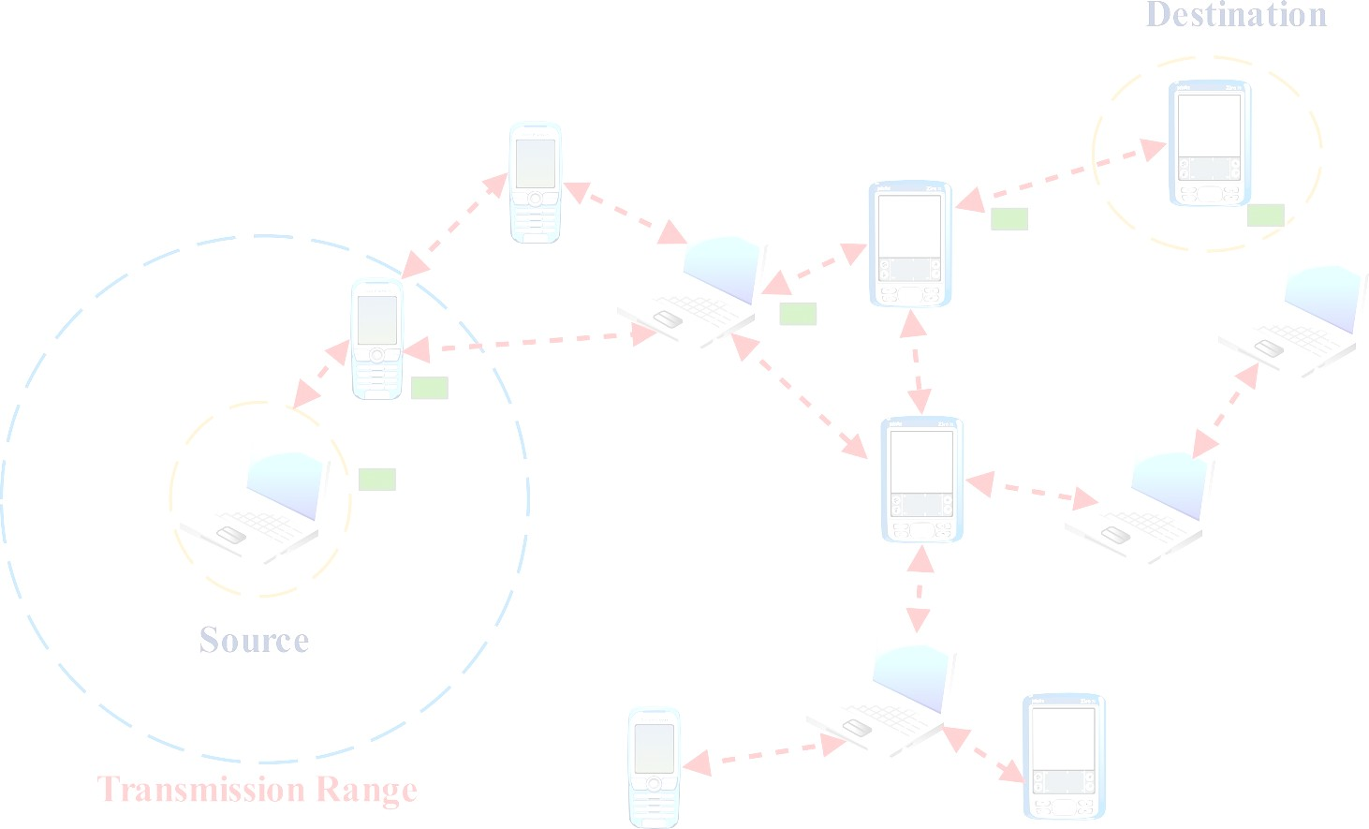

eb

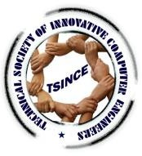

**CSIR Sponsored - Two days Virtual International workshop on Privacy - Preserving Artificial Intelligence Techniques for Machine Learning (IWAIML-21)**

**26th & 27th November 2021**

**Department of Information Technology**

**Workshop Participation: Free Registration**

**APPLICATION FORM**

(Free E-Certificate will be provided to all participants)

I would like to participate in the workshop Name:

Designation: Department: Institution/Organization:

Address:

Phone/Mobile:

Email:

DD Number & Date: Bank & Branch:

Signature of the Participant:

|  |  |  |
| --- | --- | --- |
| **Participant** | | **Registration Fee** |
| Workshop participation | | Free |
| Conference Paper Presentation | Indian Delegate | Rs.400/- |
| Foreign Delegate | Free |



**ORGANISING COMMITTEE**

**Chief Patron : Dr. M. Manickam**

**Chairman, MCET**

**Patron**

**: Shri. M. Hari Hara Sudhan Correspondent, MCET**

**Deputy Patron**

**: Dr. C. Ramaswamy Secretary, NIA Institutions**

**Chairman**

**: Dr. A. Rathinavelu Principal, MCET**

**Chairperson : Dr. S. Ramakrishnan**

**Professor & Head - IT, MCET**

**Organizing : Dr. A. B. Arockia Christopher Secretaries AP (SG) / IT**

**Dr. M. Balakrishnan AP (SG)/ IT**

**Organizing : Mr. J. Ramprasath**

**Members Mr**. **N. Praveensundar Kumar Ms. D. Janani**

**Ms. S. Soundariya Ms. G. Anandhi Ms. G. Saranya**

**Mr. C. Nandhakumar**

**Address for Communication**

**Dr. A. B. Arockia Christopher** Assistant Professor (SG), Information Technology,

Dr.Mahalingam College Engineering and

Technology, Pollachi – 642003

Mobile: 8300065828 / 9942955547

**Email:** [**iwaiml21@drmcet.ac.in**](mailto:iwaiml21@drmcet.ac.in) **[IWAIML21]**

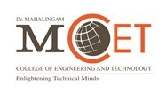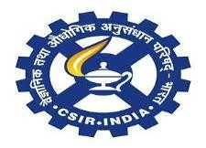

**CSIR Sponsored - Two days Virtual International workshop on Privacy - Preserving Artificial Intelligence Techniques for Machine Learning (IWAIML-21)**

**26th & 27th November 2021**

**Organized by**

**Department of Information Technology**

**Dr.Mahalingam College of Engineering and Technology**

Pollachi – 642003

An Autonomous Institution Approved by AICTE / Affiliated to Anna University

Accredited by NAAC with ‘A++’ Grade ‘Tier-1’ Accredited by NBA

Phone: 04259 - 236030, 236040

Fax: 914259-236060, 236070

[www.mcet.in](http://www.mcet.in/)





**GUIDELINES FOR PAPERS**

The authors are requested to submit the hard copy of the paper in single column format with maximum of 6 pages [Paper Size: A4, Font Type: Times New Roman, Font Size: 10 points] as well as submit the soft copy of the paper through mail [**iwaiml21@drmcet.ac.in**](mailto:iwaiml21@drmcet.ac.in)not later than November 10th 2021. First sheet should only contain the title, name(s) of the author(s), affiliation and a brief abstract between 150 to 300 words.

**REGISTRATION DETAILS**

All paper presentation delegates should register and pay the registration fee.

DD should be taken in favor of **The Principal, Dr. Mahalingam College of Engineering and Technology, Pollachi**

**(Free E-Certificate will be provided) DATES TO REMEMBER**

Last date for paper submission : 13.11.21 Date of Acceptance : 15.11.21 Last date for camera ready paper : 18.11.21

**Call for Papers**

The original and high-quality research papers are invited in the engineering research areas (but not limited to).

**All accepted, registered and presented papers of IWAIML-21 will be published in workshop proceedings. Also selected papers after further the review process will be published in UGC care listed ICTACT journals.**



**ABOUT COLLEGE**

Dr.Mahalingam College of Engineering and Technology (MCET) was established in the year 1998 by Dr.M.Manickam with a view to commemorate the 75th birth year of his beloved father Arutchelvar Dr.N.Mahalinagm with a mission to impart high quality competency based education in Engineering & Technology to the younger generation with the required skills and abilities to face the challenging needs of the industry around the globe. MCET is a self- financing, co-educational and an autonomous institution, accredited by NAAC with ‘A++’ Grade, approved by All India Council for Technical Education (AICTE), New Delhi & affiliated to Anna University. The Institute has been accredited by the National Board of Accreditation (NBA), New Delhi and ISO 9001:2000 certified by TUV. MCET currently offer 9 UG, 6 PG and 5 Doctoral Programme in Engineering, Technology and Science.

**DEPARTMENT PROFILE**

The Department of Information Technology was established in 1999, offers B.Tech (IT) programme, affiliated to Anna University and accredited by the National Board of Accreditation (NBA) & AICTE. The faculty member of department have over 100 publications in conference and journals like IEEE Transactions, Springer Verilog, Wiley IET, CSI, etc., During the last five years, the department has conducted handful of National conferences, Seminars and Skill training sponsored by AICTE, CSIR, PMKVY TI, Infosys, TNSCST.

The areas of expertise of the faculty members include information processing, Data Base Management, Software Engineering, Web Technologies and Networking, etc., our department and EMC Corporation, Bangalore have signed a MoU to provide training to the students in information storage management. Our department and SAP, Bangalore have signed a MoU to provide training for students on SAP products and business applications. Our department and VMware, Bangalore have signed a MoU to provide training for students on VMware products and business applications.

|  |  |
| --- | --- |
| **Participant** | **Registration Fee** |
| Workshop participation | Free |
| Student/Research /Scholar/ Faculty Member/ Industry Delegate (Paper Presentation) | Rs. 400/- |
| Foreign Delegate | Free |



**Track1: Artificial Intelligence**

* **AI and Decision Systems**
* **AI in Smart Cities**
* **AI in Expert Systems**
* **Fuzzy logic and systems**
* **Knowledge discovery and big data**
* **Knowledge representation**
* **Natural Language Processing**
* **Uncertainty in AI**

**Track2: Machine Learning**

* **Agile Data Science**
* **Data Mining**
* **Data Visualization**
* **Search Optimization**
* **Sentiment Analysis**
* **Swarm Intelligence**
* **Text Analytics**
* **Web Analytics**

**Track3: Cryptography and Cyber Security**

* **Database Security**
* **Digital Forensics**
* **Electronic Fraud Detection**
* **Email and Web Security**
* **Mobile Security**
* **Cloud Computing and its Security**
* **Wireless Networks**